DRAFT
List of equipment to help with the Journey
When you get MND things start to change physically. Different people are affected in different ways and the illness progresses at a different pace with each individual. I thought it may be useful to compile a list of equipment that’s out there that can help you.
Your Occupational Therapist (OT) is the first port of call when you need help with a physical activity and they are wonderful people with a great knowledge of things that can help. It is important to keep in constant contact with your assigned OT as your physical needs can change on a month to month basis. In doing this you need to be proactive. With MND things can change fast and you need to communicate with your OT on how things are progressing and what your immediate (and future) needs are.
It is helpful to get on to things early and think ahead to what you may need a short distance down the track. If you can get equipment ahead of time it gives you the opportunity to practice with the equipment.
In terms of equipment, I found “I didn’t know what I didn’t know”. That is there is equipment that is available to help which I didn’t know existed. I thought it may be helpful if I compile a list of equipment (and other things) that I have come across and could assist. This may help you in your discussions with your OT.
Some equipment is free from your Hospital and other equipment you may need to buy yourself. At time of writing this document the policy was equipment over $50 the Hospital funds, and under $50 it is left to the individual to fund. Bigger equipment items are on loan to the user until finished with. If in doubt ask your OT.
This document is meant as a guide to help and is not an exhaustive list of equipment and aides available. It is intended more as a guide you can reference when you think you have a particular need and wonder if there is equipment that could help. Please discuss your individual needs with your OT.

Equipment | How it helps | Where do you get it | Cost
- Early Stages |  |  | FF= Fully funded  On loan - from Hospital OT.  Or Self funded
Dictus Splint  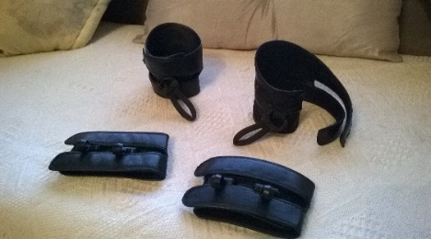 | Supports you walking. Attaches to your foot and ankle. The dictus splint stops your foot from dropping when you walk. This will help you to avoid falls and help you walk more normally. Note there are alternatives to the Dictus Splint that perform a similar function. Talk with your OT and hospital about what is most suitable for you. | Orthodics Dept. of Hospital. or Orthodics Centre | FF
 | Features: There are various options. The advantage of the Dictus Splint is that it doesn’t rub like some inserts. Comes with an attachment for use in shoes or around slippers.
Walking stick  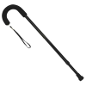  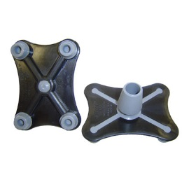 | Note there are different attachments to the walking stick available ie different feet that assist with walking and stability.  Walking sticks vary in shape and stile. One featured has soft foam grip. Height adjustable.  Sticks come with a variety of feet. The ones featured provide greater stability over uneven terrain. | Hospital OT or Mobility Shop | Self funded. Start from around $40. You can get different attachments which are extra.
Raised toilet seat  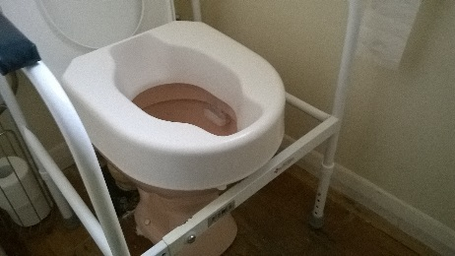 | This attachment to your normal toilet helps you to sit higher on the throne. This helps in getting on and off the toilet.  Features: Raises toilet by around 15cms to 20cm depending on seat used. | Hospital OT | On loan
Toilet frame  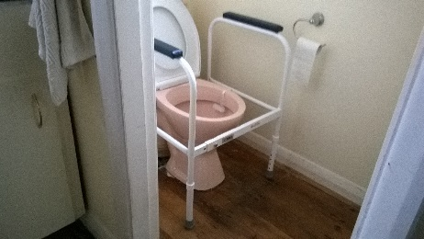 | This frame sits around your toilet and gives you some leverage when you want to stand up from the toilet. | Hospital OT | On loan
Grab Rails (bathroom)

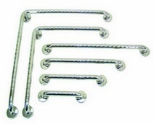

Grab rails (around the home)  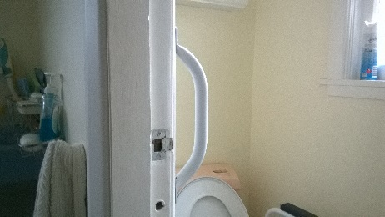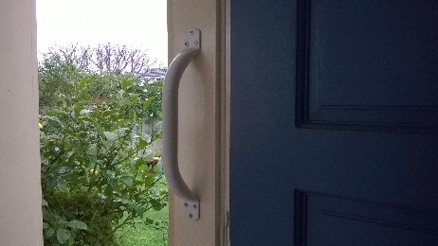  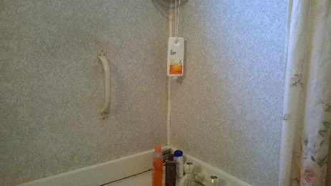 | These handles are great at different points around the home. They help you stand up and move from various heights. I found one useful in the shower while standing, by the toilet, and moving from one height to another outside eg moving from a raised deck to the ground. | Hospital OT or buy from Mobility shop | Self funded. Can buy from hospital for about $30 (with fitting an extra $30).
Walking frame  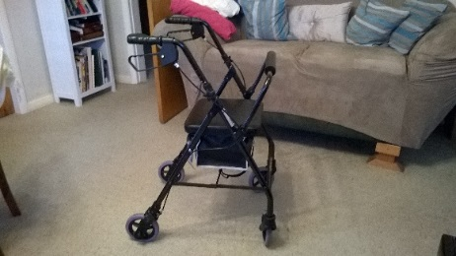 | This helps with stability and prevents falls when you get to the stage that a walking stick or two are no longer meeting your needs. Helps you remain mobile and walking as long as possible. These walking frames come with a seat (and storage underneath) built in so you can stop and take a rest from time to time. Some can be converted into a push chair (with some minor modifications). | Hospital OT | On loan
MND card/I.D bracelet | Think about what information you need to carry on you to help others know your condition eg should you have a fall in a public place and are unable to communicate your condition/needs. |  | Self funded. If over 65 available from XXX.
Transfer Board  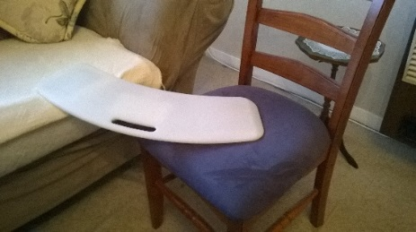 | This helps you when you are at a stage where you find it hard to transfer from one surface to another. For example move from a wheel chair to a normal seat. It stops you from accidentally falling during the transfer process.  To be used safely board must be positioned so gap between surfaces is no larger than one-third of the Board’s length. | Hospital OT | On loan
Transfer Belt  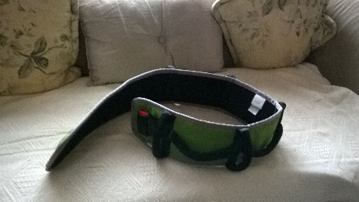  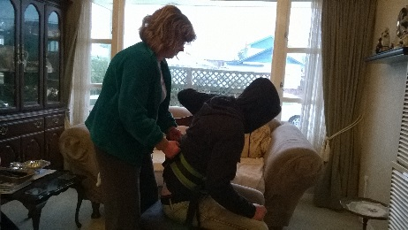 | This belt goes around your waist and helps your carer to assist with a transfer from one place to another or from one surface to another. These are not designed to hoist you but rather they assist your carer to guide you or stabilise you as you stand up or move from surface to surface.  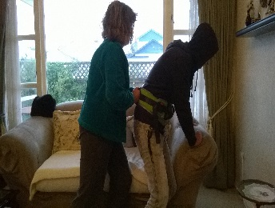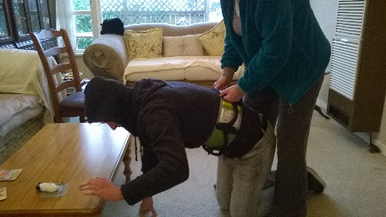 | Hospital OT | On loan
Bathroom change chair | Helpful to have a seat in the bathroom where you can sit while you dry off. | Mobility Shop | Self funded
Shower seat (for people with a shower over the bath)  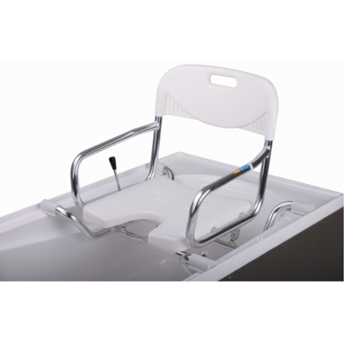 | This seat fits over your bath and allows you to sit while showering or to move from outside the shower to a seated position inside the shower. | Hospital OT | On loan
Bath Board  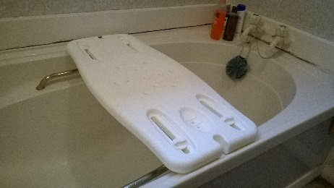 | Sits across Bath and provides a seat while showering.  Features: can be adjusted to suit various bath widths.  Useful if you still have side stomach muscles, otherwise go for shower seat. Talk to your OT about what is right for you. | Hospital OT | On loan
Grabber  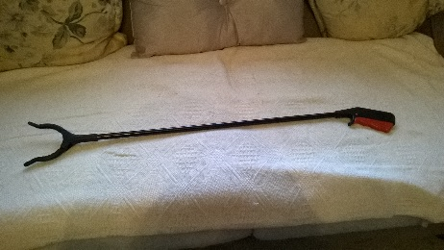 | Helpful to reach up or out to pick up things. | Various types available. Plastic ones available from $2 shops. More robust ones from local mobility shop. | Self funded
- Middle stages
Wheel chair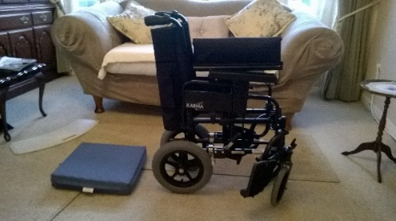 | There are two types on offer from your OT. Both are designed for around the house use. The first is a standard wheel chair which you or your carer can use to get you around the house. The other is a transfer wheel chair, which as the name suggests is used to move you from place to place, such as from the house to a car. The transfer wheelchair folds up and fits in the boot of your car. (PS make sure the wheelchair can handle steps ie can be wheeled down steps).  In addition, there are a multitude of types of wheelchair which you can purchase yourself. | OT | On loan
Motorised scooter  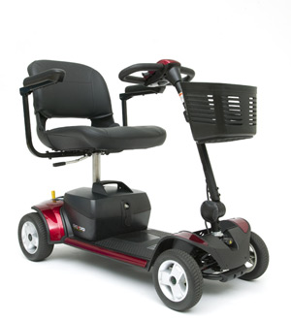  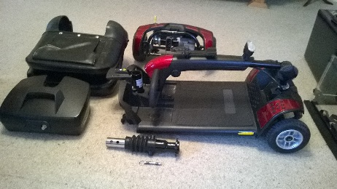 | There are a variety on the market that can help you get around. Some are large and suitable really for outside use. Some (traveller versions) can be disassembled into manageable parts and fit in the boot of your car. These can be used inside or outside the home. One advantage of the travel versions is that many can be used around the home and has a small foot-print (ie 50x100cm).  Larger the tires the greater the clearance generally. So think about where you may use it eg footpaths etc.  Four wheelers are more stable than three.  Key features (Go Go Elite Traveller featured):  - 10k-16k range.  - Easy overnight recharge from house power point.  - Front Light.  - Comes apart to five manageable pieces.  - Compact – fits most car boots.  A couple of new scooters on the market that are available from the US are the:  - The Lexis-Light Mobility Scooter  - Portashopper electric wheelchair; and  - Tek Robotic Mobilisation Device (http://www.matiarobotics.com/) | Mobility shop or on the web. | Self funded. Estimated cost Go Go Elite NZ$2,400 (new) and upward (depending upon features).  Lexis light/Easy Light Delux: US$1598 plus shipping & tax  TEK Robotic from US$15,000 plus shipping & tax.  You can pick some scooters up used on line.
Car conversions (driving without feet)  [check] | Many Cars can be converted so you can drive without the need to use your feet. Enable(a government organisation) fund car conversions where these are needed for you to remain in employment. Otherwise need to be self-funded.  See the following web site for a guide to funding -  http://www.disabilityfunding.co.nz/vehicle-and-driving | Enable – see your OT. | Funded by Enable if certain criteria are met.  Conversions are around $4,000 to $5,000 for driving hands free.
Car conversions (major)  [check] | Many vans and some Cars can be converted so you can drive into them with a wheel chair. Enable(a government organisation) may fund some car conversions.  See the following web site for a guide to funding -  http://www.disabilityfunding.co.nz/vehicle-and-driving | Enable – see your OT. | Funded by Enable if certain criteria are met.  Conversions can cost approx. $$$$
House conversions | At time of writing this document the Government subsidised house renovations necessary to help with MND. This would cover things like access ramps, bathroom alterations, and other essential alterations.  Enable fund some house modification if you meet the eligibility criteria. See the following web site for further information:  http://www.enable.co.nz/services/equipment-and-modifications-services | Enable – see your OT | The government subsidise this with the amount of subsidy being around $8,076 (incl. GST) plus. The actual amount of subsidy depends upon an income and asset test.
DVD [Living with MND – Neil Ladyman shares tips] | Neil Ladyman produced a video which is designed to help you with the management of MND. Lots of good practical advice. This DVD is available from your MND co-ordinator or from the MND association or from www….. | Available from MND Association (NZ). | Available from MND Association (NZ).
Satin/silk pyjamas & sheets | When mobility in bed becomes an issue these are really helpful to move from one position to another.  Also useful in later stages to roll a person over in bed. | Department Stores eg Farmers | Self funded
In-bed foot bridge | At some stage you may feel the weight of the blankets on your feet. The foot bridge lifts the sheets off your feet. | OT | On loan
Bed frames  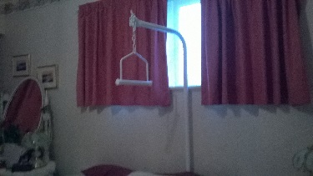  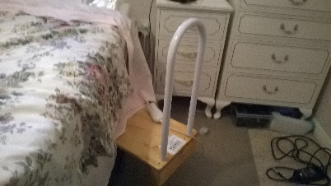 | There are various frames that are available to assist you move around while in bed. | OT | On loan
Pressure relieving mattress | At some stage you may feel pressure on your body when lying in bed. There are several good mattresses that relieve this pressure. There is a product called memory foam which is very good. Comes in various sizes and widths. | OT | Pressure mattresses are available on-loan. Others can be purchased
Chair/settee raisers  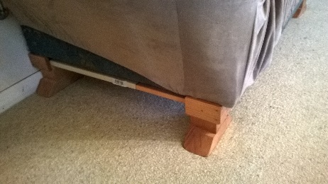  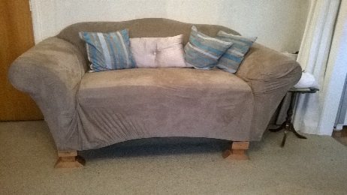 | At some stage you may find it hard getting up from chairs. Your OT will be able to provide you with one set of chair raisers which increase the height of your selected chair/settee. | OT | On loan
Wheel chair seat cushion | You may feel the need to have a seat cushion to elevate pressure points when sitting. There are various padded seat cushions available with gel and air-pocket support. If you are working at a desk they are particularly useful if spending a long time sitting down in one spot. | OT | On loan
Thermal socks | Particularly useful if you feel the cold in your feet and legs. | Department Stores, Kathmandu | Self funded
Medication to aide circulation | There are various tablets that can help ranging from Chinese herbs to things like Ginger and Garlic | Pharmacy | See your Doctor for recommendations.
Bed Pan/Toilet pot  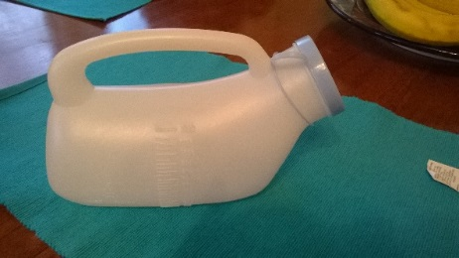 | Useful if you start to experience a weak bladder. Get one with a lid. | OT or Mobility store | Self funded
Threshold ramps  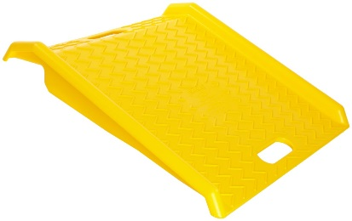  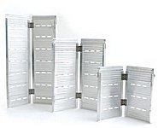 | There are various ramps available of all different lengths. One useful ramp is a plastic curb ramp which allows you to get over some (one step) thresholds. There are also other ramps that extend and some that fold down to a suit case size.  See Household renovations section above. | Disability shops or online stores | Usually self-funded  Yellow(New)=$150 on ebay.  Longer ramps $600 plus, available on-line.
Heated throw  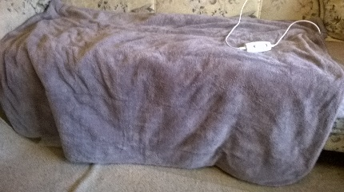 | Useful when you need to keep warm. | Department Stores eg Briscoes | Self funded. Range from $100 to $150.
- Later stages
Motorised wheel chairs |  | OT
Specialised Hospital beds for in your home |  | OT
Motorised beds |  | OT
Wheelchair commodes |  | OT
Feeding peg | An operation/procedure to help you get nutrients you need for your body to stay fit and able. Use when normal feeding by mouth becomes difficult. See your Doctor for advice. | Hospital procedure | Free
Tilt chairs  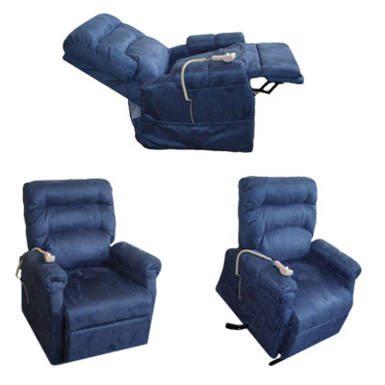 | Helps you get out of your seat. | OT
Electronic equipment | There are various electronic aides available to assist with speech or keeping in touch. There is software that can speak for you if speaking is an issue.  There is also voice activated software that coverts speech to text and gives commands to your computer. Includes Dragon Naturally Speaking ($200 to $500). Also TAZTI (which is cheaper ie around $40). Also if you have Android phone or iPhone can use Google voice conversion software built into the phone. Runs on Windows computer or Tablet. You need to train the software. [What do hospital and speech therapists use ?]
Hoists

WHAT ELSE ???

Your local Mobility shop also stocks a range of useful equipment and are worth an early visit to see what is available. You can also browse on line.
The following web sites are useful:
- http://www.mobilitycentre.co.nz/webapps/i/96725/288415/413090

Other things worth knowing:
Item/Activity |  | Comment
Condition assessment | Book yourself in with Life Unlimited (a government funded provider) for a needs assessment. | This assessment will help you to be considered for various forms of Government assistance.
Access to carer relief monies | You will at some stage need to get assistance for your career (respite care) or to generally assist around the home | When you qualify for this type of assistance ask for at least one day per Week. But more if you need it. The allocation will depend on how you
Riluzole/Rilutek | This drug may assist you to slow the progression of MND. This is fully funded by the Government if you meet their funding criteria ie it is available for certain forms of MND. | Note this drug only suits some people. The drug does not sure MND but it slows the process. Benefits of the drug vary from person to person. It is most beneficial in early stages of MND. Clinical tests show that on average it adds around three months to a person’s life expectancy.
Massey survey | Massey University conduct a survey of people with MND in order to help medical research into the cause of MND. | Massey will appreciate your assistance. A person will come to your home and help you complete a survey. The survey is also informed by their discussion with you.
MND association brouchers | An information pack that you should receive once diagnosed. Contains useful information to learn about the disease and the stages you go through.
MND association meetings | Meetings are held once a month in Lower Hutt and around the country. Come and meet with others with MND. | These meetings are a good source of friendship and advice. Also good for a laugh or two. Contact your MND co-ordinator for details.
MND national web-site
Making a will | You may like to consider this at some stage down the track but do this before you are unable. The Public Trust offers a free service as long as you name them as the executor of the will.  Just be aware that if you do not make a will then your estate will be decided by formula in legislation and this could see your monies distributed in a way you had not intended. | When you feel it’s right it is best to get this done and out the way.
Budgeting advice | Westpac has a budget calculator which can help with budgeting your finances. This can be found on line at:  https://www.westpac.co.nz/bank-accounts/calculators/budget-calculator/
Friendship and help | Friends and family are important at this time.  You can also come and meet and support others with MND at the regular branch meetings. You will find that other MND people are more than willing to help & support each other. Come and join in and share your skills and abilities. | Contact your MND field worker or the MND association for further information.
Web site , Blogs and other media | People with MND keep in touch electronically and share things through Blogs. Some good sites include:
Useful web site links | - http://www.enable.co.nz/services/equipment-and-modifications-services  - http://www.accessable.co.nz/  - New Zealand MND association  - MND chat site – see Margaret’s daughter
WHAT ELSE ???

© MND New Zealand

MND Australia list of equipment – there web site is under development in this area.
Bathroom Equipment | Shower stool
Bathroom Equipment | Shower chair
Bathroom Equipment | Mobile shower commode
Bathroom Equipment | Tilt in space mobile shower commode
Bathroom Equipment | Swivel bather
Bathroom Equipment | Bath bench
Bathroom Equipment | Over toilet frame
Bathroom Equipment | Toilet surround
Bathroom Equipment | Toilet seat raiser
Bathroom Equipment | Urinal non spill
Bedroom Equipment | Electric bed
Bedroom Equipment | Bedstick, single and double pole
Bedroom Equipment | Commode chair
Communication Aids | Buzzer/switch system
Communication Aids | Etran board
Daily Living Aids | Page turner
Furniture | Chairs  - Bridge chair  - High backed armchair  - Electric riser chair
Furniture | Tables  Around chair, overbed
Mobility Aids | Walking Frames  - Bicycle/loop brake  - Push down brake
Mobility Aids | Wheelchairs  - Manual – lightweight, transporter, recliner, tilt in space  - Electric – standard and tilt in space
Mobility Aids | Electric scooters – 4 wheel
Pressure Care | Cushions  - Roho, high and low profile  - Gel  - Foam
Pressure Care | Alternating air pressure mattresses - overlay
Pressure Care | Mattress overlay
Transfer equipment | Electric transfer/floor hoist
Transfer equipment | Slings – general purpose, head support, toileting
Other items include: bath-board, bed cradle, bedpan, nebulizer, pickup stick, magna doodle board, voice amplifier, kitchen trolley, sheepskin, transfer belt, transfer board, turning disc, ramp

